1)Implement a Shape class with method area(), and override it in Circle, Rectangle.

class Shape {

    // Method to be overridden

    public double area() {

        return 0.0;

    }

}

// Circle class

class Circle extends Shape {

    double radius;

    Circle(double radius) {

        this.radius = radius;

    }

    @Override

    public double area() {

        return Math.PI \* radius \* radius;

    }

}

// Rectangle class

class Rectangle extends Shape {

    double length, width;

    Rectangle(double length, double width) {

        this.length = length;

        this.width = width;

    }

    @Override

    public double area() {

        return length \* width;

    }

}

public class Main {

    public static void main(String[] args)

        Shape shape1 = new Circle(5.0);

        Shape shape2 = new Rectangle(4.0, 6.0);     System.out.println("Area of Circle: " + shape1.area());

        System.out.println("Area of Rectangle: " + shape2.area());

    }

}

2)Create one parent class Vehicle, and two child classes Car and Bike.

class Vehicle {

    void start() {

        System.out.println("Vehicle is starting...");

    }

}

class Car extends Vehicle {

    void drive() {

        System.out.println("Car is driving...");

    }

}

class Bike extends Vehicle {

    void ride() {

        System.out.println("Bike is riding...");

    }

}

public class Main {

    public static void main(String[] args)

        Car myCar = new Car();

        myCar.start();

        myCar.drive();       System.out.println();

        Bike myBike = new Bike();

        myBike.start();

        myBike.ride();

    }

}

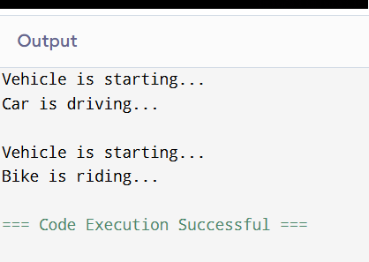

3) Create a class Employee with fields id, name, and salary. Write a method to display employee information. Create multiple employee objects and call the method.

class Employee {

    int id;

    String name;

    double salary;

    public Employee(int id, String name, double salary) {

        this.id = id;

        this.name = name;

        this.salary = salary;

    }

    public void displayInfo() {

        System.out.println("Employee ID: " + id);

        System.out.println("Name       : " + name);

        System.out.println("Salary     : " + salary);

        System.out.println("-------------------------");

    }

}

public class Main {

    public static void main(String[] args) {

        Employee emp1 = new Employee(101, "Ashwin", 45000);

        Employee emp2 = new Employee(102, "Sneha", 52000);

        Employee emp3 = new Employee(103, "Ravi", 60000);

        emp1.displayInfo();

        emp2.displayInfo();

        emp3.displayInfo();

    }

}

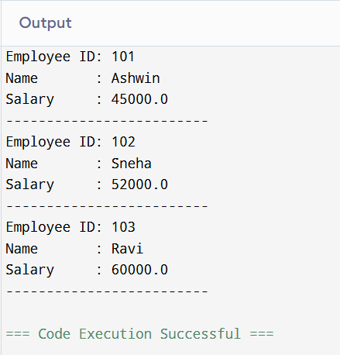

4)Write a program to create a class Calculator with methods to perform addition, subtraction, multiplication, and division. Create an object and perform all operations.

class Calculator {

    // Method for addition

    public double add(double a, double b) {

        return a + b;

    }

    // Method for subtraction

    public double subtract(double a, double b) {

        return a - b;

    }

    // Method for multiplication

    public double multiply(double a, double b) {

        return a \* b;

    }

    // Method for division

    public double divide(double a, double b) {

        if (b != 0) {

            return a / b;

        } else {

            System.out.println("Error: Division by zero");

            return 0;

        }

    }

}

public class Main {

    public static void main(String[] args) {

        Calculator calc = new Calculator();

        double num1 = 20;

        double num2 = 5;

        System.out.println("Addition: " + calc.add(num1, num2));

        System.out.println("Subtraction: " + calc.subtract(num1, num2));

        System.out.println("Multiplication: " + calc.multiply(num1, num2));

        System.out.println("Division: " + calc.divide(num1, num2));

    }

}

